**Sprint 2 Plan: Spotify X Apple Music Blend, 4/24/24**

∙ **Goal:** We want to finish up backlogged tasks from Sprint 1 ASAP so that we can implement blend creation. We also want to focus on the second user story, making the blend algorithm and getting it to work.

User story 2: As a Spotify or Apple Music user, I want to be able to make blended playlists with my friends across platforms to have fun and connect with friends.

*Task 1 [BACKLOG]: Ensure Apple Music calls can be made and received (4 hr)*

*Task 2 [BACKLOG]: Ensure Apple Music authentication works (2 hr)*

*Task 3: Basic frontend to test server side methods (6 hr)*

*Task 4: Figure out algorithm for Blend Logic (6 hr)*

*Task 5: Implement Blend algorithm (3 hr)*

*Task 6: Test Blend algorithm with our accounts and various users (5 hr)*

*Total for user story 2: 20 hours*

*Total backlog: 6 hours*

∙ **Team roles:**

*Team member 1: role 1 {, role 2, role 3}*

*Neha: Project Owner, Developer*

*Kaustubh: Developer*

*Bode: Developer*

*Justin: Developer, Scrum Master*

*Chris: Developer*

*Shayan: Developer*

∙ **Initial task assignment:**

*Team member 1: user story, initial task*

*Neha: User story 2, Task 4, Task 5, Task 2*

*Kaustubh: User story 2, Task 4, Task 6*

*Bode: User story 2, Task 4, Task 2, Task 1*

*Justin: User story 2, Task 4, Task 2, Task 1*

*Chris: User story 2, Task 4, Task 5, Task 6*

*Shayan: User story 2, Task 3, Task 4*

∙ **Initial burnup chart:**

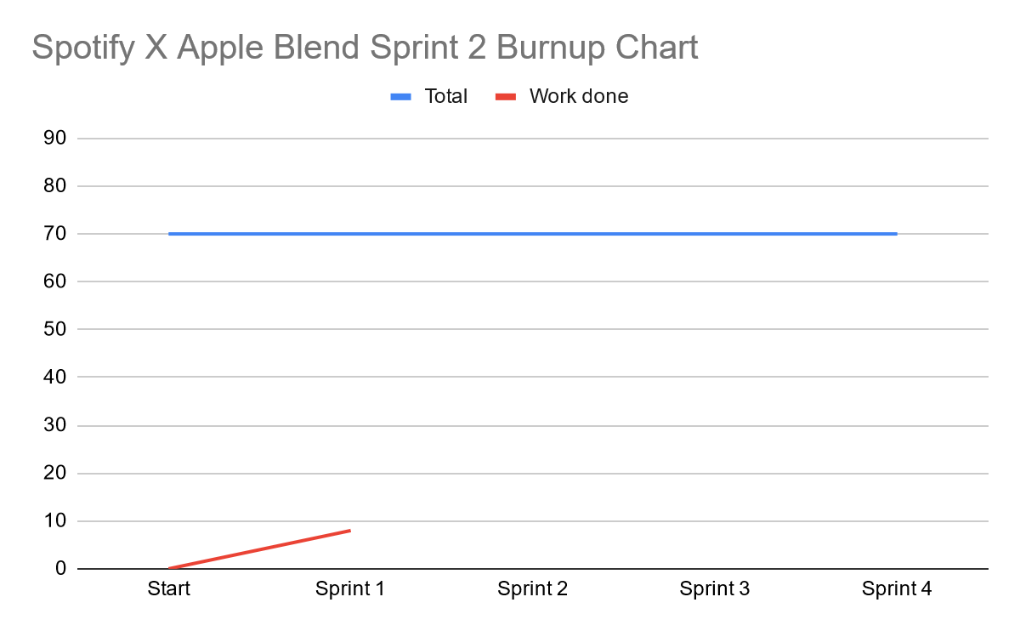

∙ **Initial scrum board:**

| **User Stories** | **Tasks Not Started** | **Tasks in Progress** | **Tasks Completed** |
| --- | --- | --- | --- |
| As a Spotify or Apple Music user, I want to be able to make blended playlists with my friends across platforms to have fun and connect with friends. | * *Task 3: Basic frontend to test server side methods (6 hr)* * *Task 4: Figure out algorithm for Blend Logic (6 hr)* * *Task 5: Implement Blend algorithm (3 hr)* * *Task 6: Test Blend algorithm with our accounts and various users (5 hr)* * *Total for user story 2: 20 hours* | * *Task 1 [BACKLOG]: Ensure Apple Music calls can be made and received (4 hr)* * *Task 2 [BACKLOG]: Ensure Apple Music authentication works (2 hr)* | * n/a |

∙ **Scrum times:**

* Thursday 6:00 - 7:00 PM TA/tutor meeting
* Saturday 1:00-2:00 PM
* Wednesday 2:00-3:00 PM